**Liberty Enlightening the World**

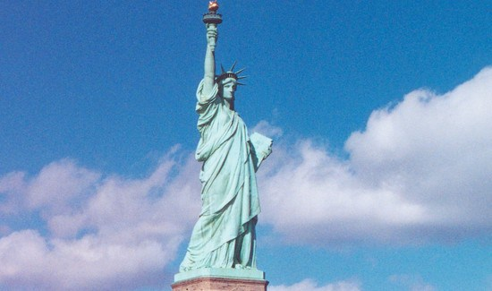

The Statue of Liberty Enlightening the World was a gift of friendship from the people of France to the people of the United States and is a universal symbol of freedom and democracy. The Statue of Liberty was dedicated on October 28, 1886, designated as a National Monument in 1924 and restored for her centennial on July 4, 1986.